# Australia

Ranking of AUS unis

<https://www.topuniversities.com/university-rankings-articles/world-university-rankings/top-universities-australia-2020>

Basically all require GPA of 7.0 or higher

General observation: on campus accomodation is really expensive but good, private housing is cheaper but not necessarily same standard.

## macquire university

ranking: 200-250 in the world

courses:

human biology <http://handbook.mq.edu.au/2019/Units/UGUnit/BIOL108>

bio basis of behavior <http://handbook.mq.edu.au/2019/Units/UGUnit/BIOL122>

neurophysiology!!! <http://handbook.mq.edu.au/2019/Units/UGUnit/BIOL257>

neuroanatomy <http://handbook.mq.edu.au/2019/Units/UGUnit/HLTH214>

cognitive science afdeling: <http://handbook.mq.edu.au/2019/Units/UGByFaculty/Faculty+of+Human+Sciences>

<https://courses.mq.edu.au/2020/domestic/undergraduate/bachelor-of-cognitive-and-brain-sciences/course-structure#content>

academic calendar:

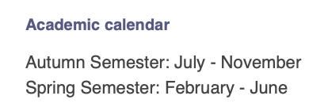

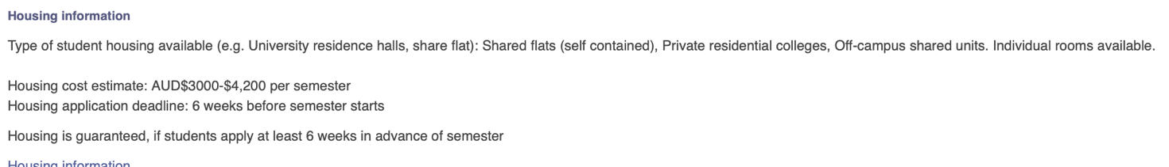

## Deakin university – Melbourne

Really good orientation trip it seems

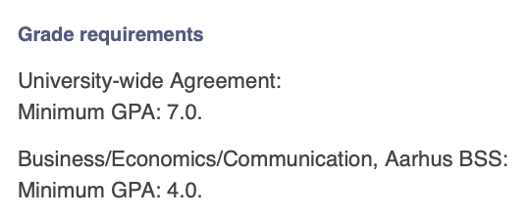

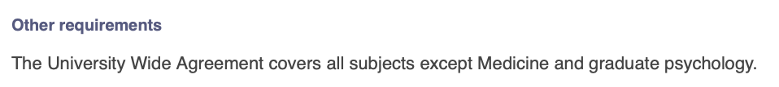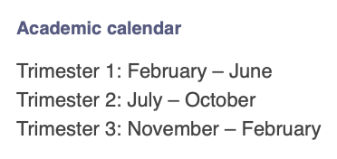

Courses:

Psychology:

<https://www.deakin.edu.au/current-students-courses/course.php?course=H344&version=1&year=2020#CRS-STRUCTURE-UNITS>

<https://www.deakin.edu.au/current-students-courses/course.php?course=H344&version=2&year=2020#CRS-STRUCTURE-UNITS>

social psychology: <https://www.deakin.edu.au/current-students-courses/unit.php?unit=HPS204&year=2020&return_to=%2Fcurrent-students-courses%2Fcourse.php%3Fcourse%3DH344%26version%3D1%26year%3D2020>

bio psychology

<https://www.deakin.edu.au/current-students-courses/unit.php?unit=HPS310&year=2020&return_to=%2Fcurrent-students-courses%2Fcourse.php%3Fcourse%3DH344%26version%3D2%26year%3D2020>

cells and genes <https://www.deakin.edu.au/current-students-courses/unit.php?unit=SLE111&year=2020&return_to=%2Fcurrent-students-courses%2Fcourse.php%3Fcourse%3DS320%26version%3D4%26year%3D2020>

human biology: <https://www.deakin.edu.au/current-students-courses/detail.php?customer_cd=C&service_item=S320&version_number=4&element_cd=MAJORS-STRUCTURE&sub_item_number=14&year=2020&return_to=%2Fcurrent-students-courses%2Fcourse.php%3Fcourse%3DS320%26version%3D4%26year%3D2020>

AI course

<https://www.deakin.edu.au/current-students-courses/course.php?course=S308&version=1&year=2020#OVERVIEW>

Intro to AI: <https://www.deakin.edu.au/current-students-courses/unit.php?unit=SIT114&year=2020&return_to=%2Fcurrent-students-courses%2Fcourse.php%3Fcourse%3DS308%26version%3D1%26year%3D2020>

NO PURE NEUROSCIENCE

## RMIT University (Royal Melbourne Institute of Technology)

Midt I Melbourne, ingen on campus housing, men stadig pisse dyrt at bo der.

Courses:

Biomedical science

<https://www.rmit.edu.au/study-with-us/levels-of-study/undergraduate-study/bachelor-degrees/bachelor-of-biomedical-science-bp231/bp231p10ausbu>

cell biology: <https://www.rmit.edu.au/study-with-us/levels-of-study/undergraduate-study/bachelor-degrees/bachelor-of-biomedical-science-bp231/bp231p10ausbu>

microbiology: <https://www.rmit.edu.au/study-with-us/levels-of-study/undergraduate-study/bachelor-degrees/bachelor-of-biomedical-science-bp231/bp231p10ausbu>

biochemistry: <https://www.rmit.edu.au/study-with-us/levels-of-study/undergraduate-study/bachelor-degrees/bachelor-of-biomedical-science-bp231/bp231p10ausbu>

human physiology: <https://www.rmit.edu.au/study-with-us/levels-of-study/undergraduate-study/bachelor-degrees/bachelor-of-biomedical-science-bp231/bp231p10ausbu>

biochemistry and molecular biology: <https://www.rmit.edu.au/study-with-us/levels-of-study/undergraduate-study/bachelor-degrees/bachelor-of-biomedical-science-bp231/bp231p10ausbu>

(biological) neuroscience: <https://www.rmit.edu.au/study-with-us/levels-of-study/undergraduate-study/bachelor-degrees/bachelor-of-biomedical-science-bp231/bp231p10ausbu>

Doesn’t look like they have pure neuroscience courses!!

IT course:

<https://www.rmit.edu.au/study-with-us/levels-of-study/undergraduate-study/bachelor-degrees/bachelor-of-information-technology-bp162/bp162opn9auscy>

computer science course: <https://www.rmit.edu.au/study-with-us/levels-of-study/undergraduate-study/bachelor-degrees/bachelor-of-computer-science-bp094/bp094gen8auscy>

(both above have AI elements)

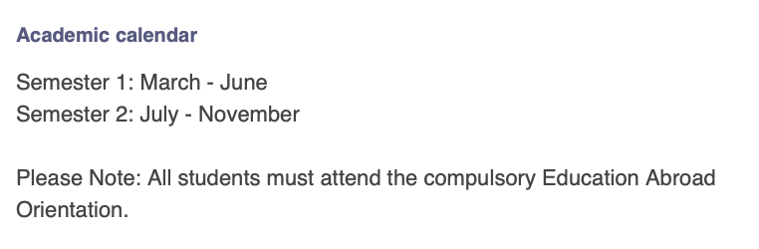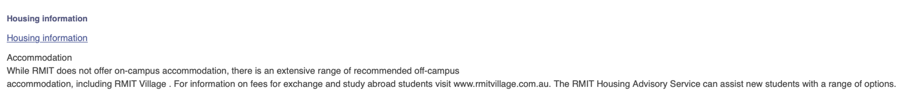

## university of Wollongong

* University city
* Ranking: top 200-250 in the world

**Academic calendar**

The autumn semester runs from ultimo February - ultimo June.   
  
The spring semester runs from ultimo July - ultimo November.

Housing: available on campus <https://documents.uow.edu.au/content/groups/public/@web/@accomm/documents/doc/uow258660.pdf>

200 dollars pr week

Courses:

BIOL103 **-** Molecules, Cells and Organisms

<https://solss.uow.edu.au/apir/public_subjectview.subject_info_view?p_subject_code=BIOL103>

fundementals of neuroscience (mere biologisk rettet tror jeg)

<https://solss.uow.edu.au/apir/public_subjectview.subject_info_view?p_subject_code=MEDI312>

introduction to biomedical physics

<https://solss.uow.edu.au/apir/public_subjectview.subject_info_view?p_subject_code=PHYS155>

principles of biochemistry

<https://solss.uow.edu.au/apir/public_subjectview.subject_info_view?p_subject_code=BIOL213>

cell and molecular biology

<https://solss.uow.edu.au/apir/public_subjectview.subject_info_view?p_subject_code=BIOL340>

introduction to anatomy and physiology

<https://solss.uow.edu.au/apir/public_subjectview.subject_info_view?p_subject_code=MEDI112>

kinda same as above: human structure and function

<https://solss.uow.edu.au/apir/public_subjectview.subject_info_view?p_subject_code=MEDI100>

Biological Psychology and Learning

<https://solss.uow.edu.au/apir/public_subjectview.subject_info_view?p_subject_code=PSYC234>

developmental and personality psychology

<https://solss.uow.edu.au/apir/public_subjectview.subject_info_view?p_subject_code=PSYC241>

advanced cognitive psychology

<https://solss.uow.edu.au/apir/public_subjectview.subject_info_view?p_subject_code=PSYC327> ‘

psychopharmacology

<https://solss.uow.edu.au/apir/public_subjectview.subject_info_view?p_subject_code=PSYC359>

psychophysiology

<https://solss.uow.edu.au/apir/public_subjectview.subject_info_view?p_subject_code=PSYC329>

# University of Technology Sydney (UTS)

Generelt indtryk: MEGET science

**Academic calendar**

Semester 1: March - July.   
Semester 2: July – November.

Courses:

<http://handbook.uts.edu.au/subjects/91161.html>

# The University of Western Australia - Perth, Australia

Seemingly few restrictions on what courses one can choose!

<https://arts.augo.au.dk/Institution/Main/4333>

ranking: #86

accommodation: <https://www.unihall.uwa.edu.au/rooms> (expensiiiiveee)

courses:

courses in neuroscience major: <https://www.uwa.edu.au/study/courses/neuroscience>

molecular biology of the cell

<https://handbooks.uwa.edu.au/unitdetails?clearc=1&code=SCIE1106>

human neurobiology

<https://handbooks.uwa.edu.au/unitdetails?clearc=1&code=ANHB2217>

Biochemistry and molecular biology courses:

<https://www.uwa.edu.au/study/courses/biochemistry-and-molecular-biology>

biological chemistry

<https://handbooks.uwa.edu.au/unitdetails?clearc=1&code=CHEM1004>

psychology courses:

<https://www.uwa.edu.au/study/courses/psychological-science>

cognitive neuroscience <https://handbooks.uwa.edu.au/unitdetails?clearc=1&code=PSYC3317>

social psychology: <https://handbooks.uwa.edu.au/unitdetails?clearc=1&code=PSYC3312>

## The University of New South Wales Kensington, Sydney, Australia

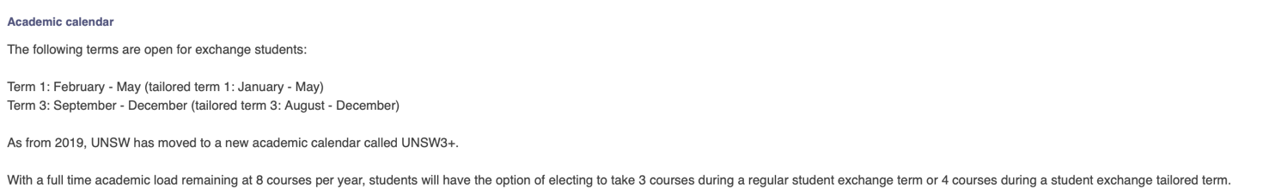

Academic calendar: 3 semesters a year

<https://student.unsw.edu.au/calendar>

ranking:

Accommodation costs: <https://www.international.unsw.edu.au/cost-of-living>

COURSES

General course overview: nice and tidy!!! (OBS 2016 edition)

<http://timetable.unsw.edu.au/2016/subjectSearch.html>

2020 handbook!

<https://www.handbook.unsw.edu.au>

neuroscience major courses:

<https://www.handbook.unsw.edu.au/undergraduate/specialisations/2020/NEURS1?q=neuroscience&ct=all>

* Moelcules, cells and genes: <https://www.handbook.unsw.edu.au/undergraduate/courses/2020/BABS1201/>
* Physiology: <https://www.handbook.unsw.edu.au/undergraduate/courses/2020/PHSL2101/>
* Molecular and ecellular neuroscience <https://www.handbook.unsw.edu.au/undergraduate/courses/2020/NEUR3121/>

Psychology courses: <https://www.handbook.unsw.edu.au/undergraduate/programs/2020/3435?browseByInterest=34054293db96df002e4c126b3a9619ee&>

* Cognitive science
* <https://www.handbook.unsw.edu.au/undergraduate/courses/2020/PSYC3211/?q=decision%20making&ct=all>
* Innovative minds: <https://www.handbook.unsw.edu.au/postgraduate/courses/2020/PSYC5101/?q=cognitive%20science&ct=all>

## Australian national university

Canberra – hælder mod den her lige nu 15/10-19

Courses:

<https://programsandcourses.anu.edu.au/2020/course/BIOL2174> cell physiology

<https://programsandcourses.anu.edu.au/2020/course/NEUR3101> cellular neuroscience

systems neuroscience <https://programsandcourses.anu.edu.au/2020/course/NEUR3112> (brigding high and low level neuroscience)

cell and molecular biology major courses:

<https://programsandcourses.anu.edu.au/2020/major/CMBI-MAJ>

psychology major courses:

<https://programsandcourses.anu.edu.au/2020/major/PSYC-MAJ>

biological neuropsychology minor

<https://programsandcourses.anu.edu.au/2020/minor/BION-MIN>

# CANADA

## Brock university

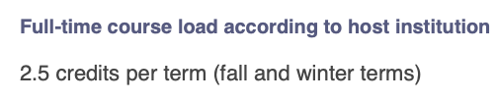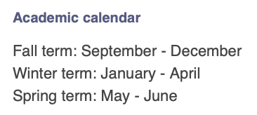

COURSES

Svært at finde ud af hvilke subjects der er under hver major :////

Neuroscience major: <https://brocku.ca/programs/undergraduate/neuroscience/>

<https://brocku.ca/webcal/undergrad/neur.html>

mere uddybet: <https://brocku.ca/webcal/2019/undergrad/neur.html#NEUR_1P01>

!!!! **#NEUR 3P34**

**Neurobiology**

(also offered as [BIOL 3P34](https://brocku.ca/webcal/2019/undergrad/biol.html#BIOL_3P34))

Structure and function of nerve cells: Electrical properties of neurons, synaptic function and transmitters, neural plasticity and cellular basis of behaviour.

Neuropsychology and neuropharmacology looks interesting

BIOLOGICAL SCIENCES:

<https://brocku.ca/webcal/2019/undergrad/biol.html#BIOL_2P02>

**BIOL 2P02 + 03**

**Introduction to Molecular Biology + cell biology**

## Concordia university, Montreal

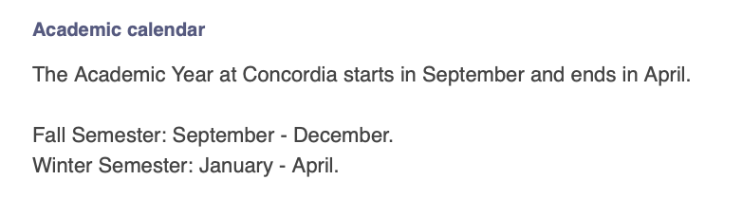

COURSES

No seeming neuroscience

Psychology: <https://www.concordia.ca/academics/undergraduate/calendar/current/sec31/31-250.html#courses>

Biologi: <https://www.concordia.ca/academics/undergraduate/calendar/current/sec31/31-030.html#courses>

**BIOL 266      *Cell Biology***



Chemistry and biochemistry: <https://www.concordia.ca/academics/undergraduate/calendar/current/sec31/31-050.html#courses>

## CREPUQ

Skipped because majority is in French

## Dalhousie – Halifax, nova scotia

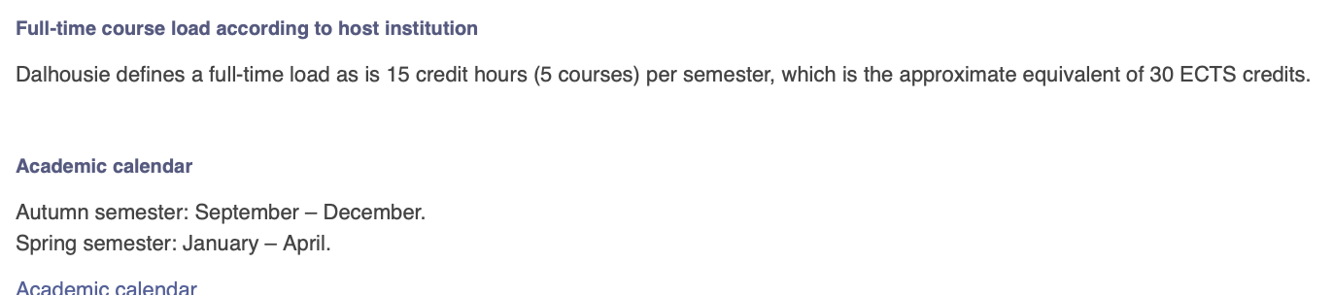

COURSES

Neuroscience: <https://dalonline.dal.ca/PROD/fysktime.P_DisplaySchedule?s_term=202010,202020&s_subj=NESC&s_district=All>

* Systems + cellular neuroscience sound interesting

Biochem and molecular biology:

<https://dalonline.dal.ca/PROD/fysktime.P_DisplaySchedule?s_term=202010,202020&s_subj=BIOC&s_district=All>

* There are introductory courses

Computer science:

<https://dalonline.dal.ca/PROD/fysktime.P_DisplaySchedule?s_term=202010,202020&s_subj=CSCI&s_district=All>

MRI stuff (seems pretty advanced tho)

<https://dalonline.dal.ca/PROD/fysktime.P_DisplaySchedule?s_term=202010,202020&s_subj=MRIT&s_district=All>

physiology:

<https://dalonline.dal.ca/PROD/fysktime.P_DisplaySchedule?s_term=202010,202020&s_subj=PHYL&s_district=All>

neurophysiology: <https://academiccalendar.dal.ca/Catalog/ViewCatalog.aspx?pageid=viewcatalog&topicgroupid=20530&entitytype=CID&entitycode=PHYL+2570>

statistics – there is some time-series analysis stuff in the bottom that could be interesting

<https://dalonline.dal.ca/PROD/fysktime.P_DisplaySchedule?s_term=202010,202020&s_subj=STAT&s_district=All>

# University of Manitoba

Mange courses er på frnask – overvej hvor meget fransk fylder I qubec’s hverdag og hvor store n udfording det potentielt kan være

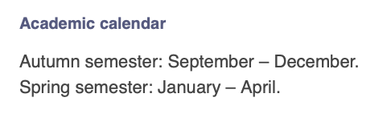

INPUT FROM PSYCH STUDENT

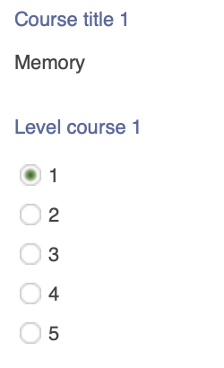

Courses: se pdf I ITTU folder

Der er noget physiology, cell biology, etc

Affective neuroscience (under psychology) lyder interessant

## University of Ottawa

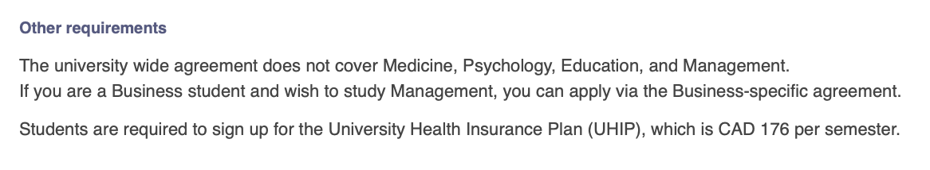

COURSES

Couldn’t access

## University of western Ontario

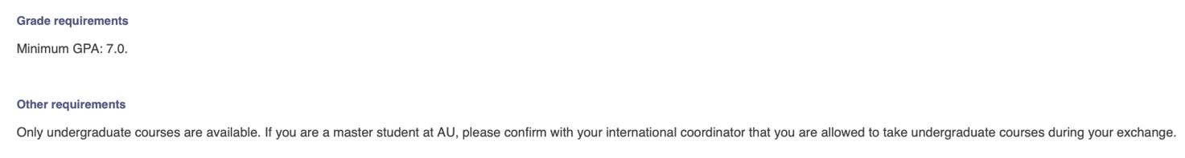

COURSES

Science overview:

<http://www.westerncalendar.uwo.ca/Courses.cfm>

Neuroscience:

<http://www.westerncalendar.uwo.ca/Courses.cfm?Subject=NEURO&SelectedCalendar=Live&ArchiveID=>

physiology:

<http://www.westerncalendar.uwo.ca/Courses.cfm?Subject=PHYSIOL&SelectedCalendar=Live&ArchiveID=>

biochemistry:

<http://www.westerncalendar.uwo.ca/Courses.cfm?Subject=BIOCHEM&SelectedCalendar=Live&ArchiveID=>

anatomy and cell biology:

<http://www.westerncalendar.uwo.ca/Courses.cfm?Subject=ANATCELL&SelectedCalendar=Live&ArchiveID=>

psychology:

<http://www.westerncalendar.uwo.ca/Courses.cfm?Subject=PSYCHOL&SelectedCalendar=Live&ArchiveID=>

# Chile

# Costa Rica

Underviser kun på spansk – udelukket

# Mexico

Begge universiteter underviser kun på spansk

# Spanien

Underviser på engelsk, spansk og catalansk

# Uruguay

Også kun spansk

# Tjekkiet

Søgemaskine foregår på tjekkisk

Psychology: <https://is.cuni.cz/studium/eng/predmety/index.php?do=search&dlpar=YToxOntzOjg6InByZWRtZXR5IjthOjE6e3M6Mzoic2tyIjtzOjQ6IjIwMTUiO319&nazev=psychology&kod=&match=substring&srch_nazev=0&srch_nazev=1&fak=11000&ustav=&sekce=&trida=&klas=&ujmeno=&utyp=3&pvyjazyk=ENG&sem=&pocet=20&b=Search>

# Singapore

## Nayang technological university

Den værste course selection længe omggggg

## National university

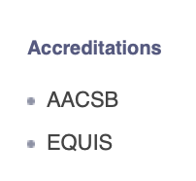

Neuroscience courses

OBS !!! NUS har egen dykker klub!

<https://www.facebook.com/nusdiveclub/>

OBS tjek op på i hvilke semestre hvilke fag ligger!!! Om det kun er semester 1

# Tyskland

## Osnabruck

Har special aftale med cogsci!

Men underviser på tysk

Courses:

<https://www.uni-osnabrueck.de/fileadmin/documents/public/1_universitaet/1.2_zahlen_daten_fakten/vpv/vv_SoSe_2019_Mai.pdf>

courses in english:

<https://www.uni-osnabrueck.de/en/studies/study_courses.html>

men ligner deres cogsci undervises på engelsk måske? (skriv til dem)

<https://arts.augo.au.dk/Institution/Main/284>

## Christian-Albrechts-Universitat zu Kiel

<https://arts.augo.au.dk/Institution/Main/257>

kun islam studier i spring 2020 ser det ud til, ikke all subjects arts – og alle andre aftaler er ikke university wide.

# Israel

## Tel aviv university

Meget begrænset course catalogue

## The Hebrew University of Jerusalem

Also seemingly strict AU requirements = big workload.

Also seemingly limited course catalogue

# New Zealand

## The University of Auckland

Semester from start march to end June

Course list: <http://www.student.guest.auckland.ac.nz/psc/ps/EMPLOYEE/SA/c/UOA_COMMUNITY_ACCESS_FL.UOA_BRWSE_CTLG_FL.GBL?languageCd=ENG>

There are quite a few interesting psychology courses

<http://www.student.guest.auckland.ac.nz/psc/ps/EMPLOYEE/SA/c/UOA_COMMUNITY_ACCESS_FL.UOA_BRWSE_CTLG_FL.GBL?languageCd=ENG>

computational biology:

<http://www.student.guest.auckland.ac.nz/psc/ps/EMPLOYEE/SA/c/UOA_COMMUNITY_ACCESS_FL.UOA_BRWSE_CTLG_FL.GBL?languageCd=ENG>

AI course:

<http://www.student.guest.auckland.ac.nz/psc/ps/EMPLOYEE/SA/c/UOA_COMMUNITY_ACCESS_FL.UOA_BRWSE_CTLG_FL.GBL?languageCd=ENG>

intro biochemistry

<http://www.student.guest.auckland.ac.nz/psc/ps/EMPLOYEE/SA/c/UOA_COMMUNITY_ACCESS_FL.UOA_BRWSE_CTLG_FL.GBL?languageCd=ENG>

cellular and molecular biology

<http://www.student.guest.auckland.ac.nz/psc/ps/EMPLOYEE/SA/c/UOA_COMMUNITY_ACCESS_FL.UOA_BRWSE_CTLG_FL.GBL?languageCd=ENG>

maybe some economics courses? <http://www.student.guest.auckland.ac.nz/psc/ps/EMPLOYEE/SA/c/UOA_COMMUNITY_ACCESS_FL.UOA_BRWSE_CTLG_FL.GBL?languageCd=ENG> – game theory

behavioral economics

<http://www.student.guest.auckland.ac.nz/psc/ps/EMPLOYEE/SA/c/UOA_COMMUNITY_ACCESS_FL.UOA_BRWSE_CTLG_FL.GBL?languageCd=ENG>

# Poland

<https://arts.augo.au.dk/Institution/Main/3303>

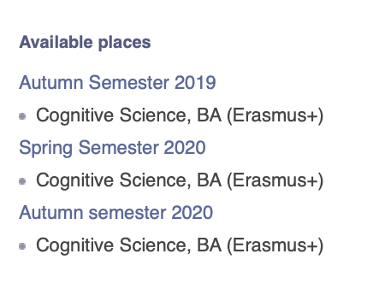

Så seemingly ren cogsci eller arts

# United Kingdom

## Manchester university

Courses:

Says they have neuroscience, but site was not found

Bachelor in neuro:

<https://www.manchester.ac.uk/study/undergraduate/courses/2020/00617/bsc-neuroscience/>

form course selection:

psychology

<https://www.manchester.ac.uk/study/undergraduate/courses/2020/00653/bsc-psychology/course-details/>

biological sciences / biochem

<https://www.bmh.manchester.ac.uk/visiting-students/course-units/>

## University of Liverpool

Ikke university wide agreement – så kun arts subjects?

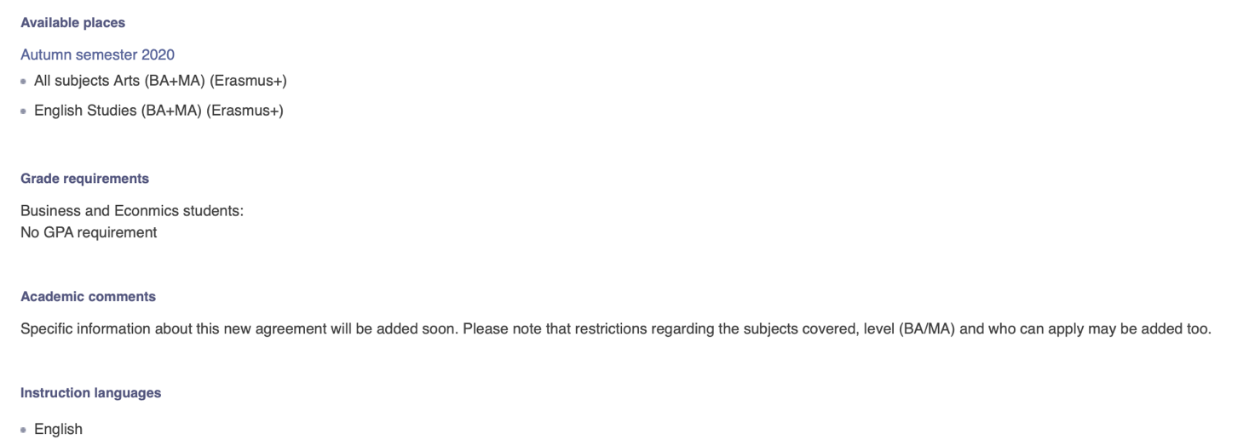

Psychology: <https://www.liverpool.ac.uk/study/undergraduate/courses/psychology-bsc-hons/module-details/>

Physiology

<https://www.liverpool.ac.uk/study/undergraduate/courses/physiology-bsc-hons/module-details/>

## University of East Anglia, Norwich

Courses

<https://www.uea.ac.uk/study/study-abroad/incoming/modules>

Spring psych:

<http://www.uea.ac.uk/documents/2654296/5385838/PSY+Spring+2019-20.pdf/99e51db0-d380-9621-be63-9a1cfa768bb1>

spring bio

<https://www.uea.ac.uk/documents/2654296/5385838/BIO+Spring+2019-20.pdf/e6227fa8-1b4a-b7ab-f8c3-8d961681a3f2>

economics spring

<https://www.uea.ac.uk/documents/2654296/5385838/ECO+Spring+2019-20.pdf/a75a3836-4266-6995-1e38-14fc81b84912>

incl behavioral economics

# Norway

## Bergen

Different cogsci’s have gone here

<https://arts.augo.au.dk/Institution/Main/19>

courses

<https://rapport-dv.uhad.no/t/UiB/views/Emnelisteforinnreisendeutvekslingsstudenter/Coursesforexchangestudents?%3Aembed=y&%3AshowAppBanner=false&%3AshowShareOptions=false&%3Adisplay_count=no&%3AshowVizHome=no&%3Atoolbar=no&%3Alinktarget=_self>

cellular neuroscience

<https://www.uib.no/en/course/BMED340> - but only master students?

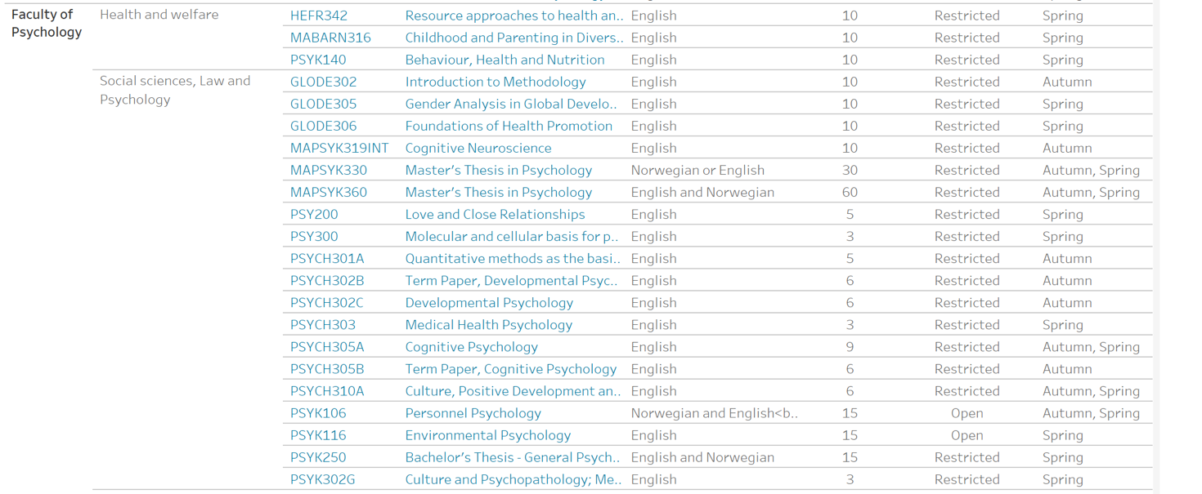

## UiT The Arctic University of Norway

# USA

## San Francisco State University

Bilateral agreement

## University of Vermont

Se course selection document for courses.

https://www.uvm.edu/cas/neuro

Neuroscience

<https://www.uvm.edu/academics/courses/?term=202001&subject=NSCI&number=&text=&instructor=&instructor_id=&start=&start_meridium=am&end=&end_meridium=am&days%5B%5D=Monday&days%5B%5D=Tuesday&days%5B%5D=Wednesday&days%5B%5D=Thursday&days%5B%5D=Friday&days%5B%5D=Saturday&days%5B%5D=Sunday&dayOperator=or&action=Search>